,,,MNFrequently Asked Questions for TLVA

Q.1- What is the process for get access for TLVA Portal?
Ans:- Need a new SR form through wired portal
Q.2- How to Modify personal details/roles/circle in TLVA user id?
Ans:- Any type of any changes in user profile like mobile number, add or remove Roles, add or remove Circle then raise a SR form application through wired Portal.
E.g. 1. You have “MIS Role” role and now you want “TLVA Planning” role.
E.g. 2. You have “Haryana” circle and now you want to add “Punjab” and “Himachal Pradesh” circles.

Q.3- How to reset the password in TLVA?
Ans:- For reset password you need to follow following steps
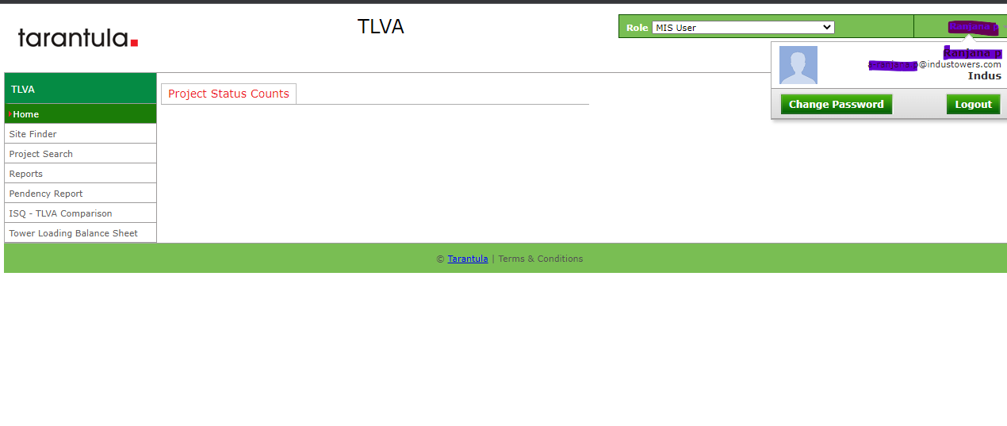
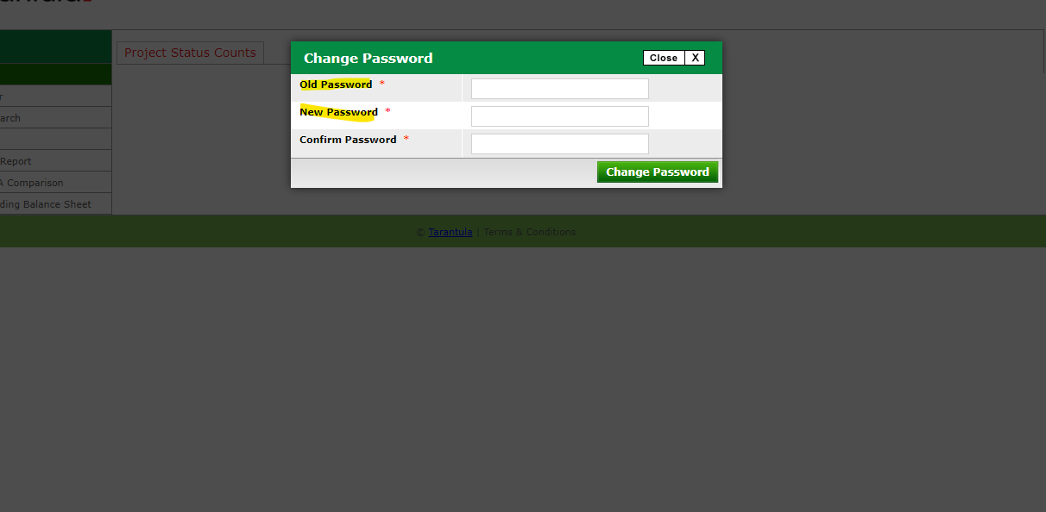

Q.4- How to change TLVA milestone status?
Ans:- If you have change TLVA milestone status or revoke, the you will be need raise a SR form for TLVA Milestone change in TLVA Portal.
Q.5- Site is not visible to Partner/Vendor?
Ans:- If some site is not visible to partner or you need to change partner name change in TLVA Portal. Then need to be raise SR form for Partner name change in TLVA Portal.
Q.6-How to capacity full Un-tagging in TLVA?
Ans:- If some sites need Un-tag 0r tag from Capacity full then need to raise SR form for capacity full un-tagging in TLVA.

